Mick Shoulder – Bass Player
www.mickshoulder-bassplayer.com
BIO:
Mick began at about the age of nine by playing classical guitar and indeed not much else until Punk exploded onto the scene in his mid-teens. He ended up as the bass player in 'Citizen Kane'. The reasoning being;, "if you can play guitar, then you must be able to play bass" He soon figured out that he enjoyed it more than playing guitar. After some dodgy haircuts and a failed recording contract the band split and reformed a few years later. This time, just to play some blues for fun. It was during this period that Mick became enamoured with Rockabilly, took up double bass and started to get into the jazzier end of RnB. They eventually split up for good eight years, two albums and 1500 gigs later. A brief respite was in order to regroup and practice. During this period Mick dug out his guitar, practiced his jazz chops, learnt to read music and performed a lot of gigs as a jazz guitarist. A return to bass guitar was followed by a brief sojourn and minor record deal with metal band, 'Voodoo Guru' and then Mick joined 'The Whisky Priests'. The next year was spent endlessly touring Europe with the odd jazz gig at home when time allowed. Mick left after a year to join Frank Zappa tribute band 'Wagga Jawaka'. This was a labour of love for the next three years. When 'Wagga’ finally folded he decided to concentrate solely on Jazz.

Many gigs throughout the North East followed with his own quintet and many of the region’s finest players. He was part of 'The Dave Borthwick Trio'. The band which recorded the first album on the 'Jazz Action' label which has since gone on to chronicle the cream of the North East's talent.
He formed 'Djangologie' at the start of the century, (Who also recorded on the 'Jazz Action' label) who after a short hiatus have gone on to forge a national reputation on the Gypsy Jazz circuit and were selected as one of only twelve bands on the first 'Northern Line' scheme. Mick also still indulges his passion for guitar by playing his Maccaferri copy with the band when one of their regular guitarists is unavailable. He has since went on to form 'Mick Shoulder's Swing Manouche'. Another gypsy jazz outfit, this time with Mick taking over lead guitar duties. He is also a member of the 'Paul Edis Sextet' A piano player with a growing national reputation, the band has recorded two albums. The first of which gained third place in the 2012 'Jazzwise' poll. Also, with the 'Ruth Lambert Trio', an intimate vocal/guitar/bass outfit which won the ‘BBC Introducing’ jazz category and is featured with 'Musicians Unlimited' big band.

In his "spare time" he does the occasional gig with the 'Mick Shoulder Quintet' playing the music of the Jazz Messengers/Jazz Couriers/Horace Silver. The nine piece 'Mick Shoulder Little Big Band' playing a cross between Rockabilly and big band and his funk/improv/dance outfit 'Tug' As well as this, he is a composer, arranger, teacher, plays with a variety of local outfits and also performs as a theatre musician.

Mick has worked and played with

David Newton Trio, Greg Abate, Alan Barnes, Bruce Adams, Jim Mullen, Tony Kofi, Mornington Lockett, Tim Garland, Julian Siegal, Dave O'Higgins, Gerard Presencer, Nigel Price, Pete Churchill, Steve Waterman, Dave Cliff, Tommy Whittle, Mark Nightingale, Daniel John Martin, Christophe Brunard, Ben Castle, Dennis Rollins, Tim Whitehead, Harry Beckett, Jason Yarde, Frank Brooker,Vasilis Xenapoulis, Lennart Anderson, Roy Williams, John Barnes. He has also been featured with numerous large ensembles, such as ‘Voice of the North’, ‘Dave Connolly Big Band’, Musicians Unlimited, John Miles Big Band and Jools Holland.
PHOTOS:

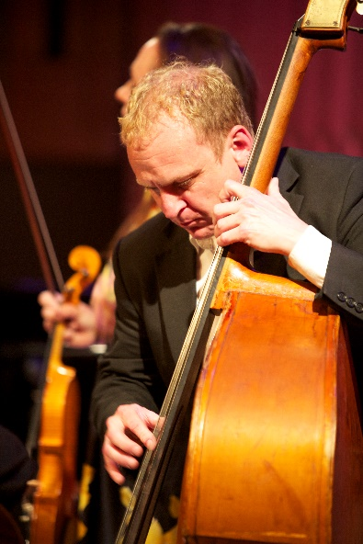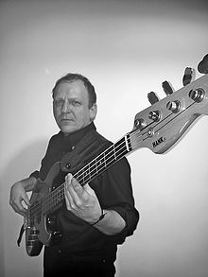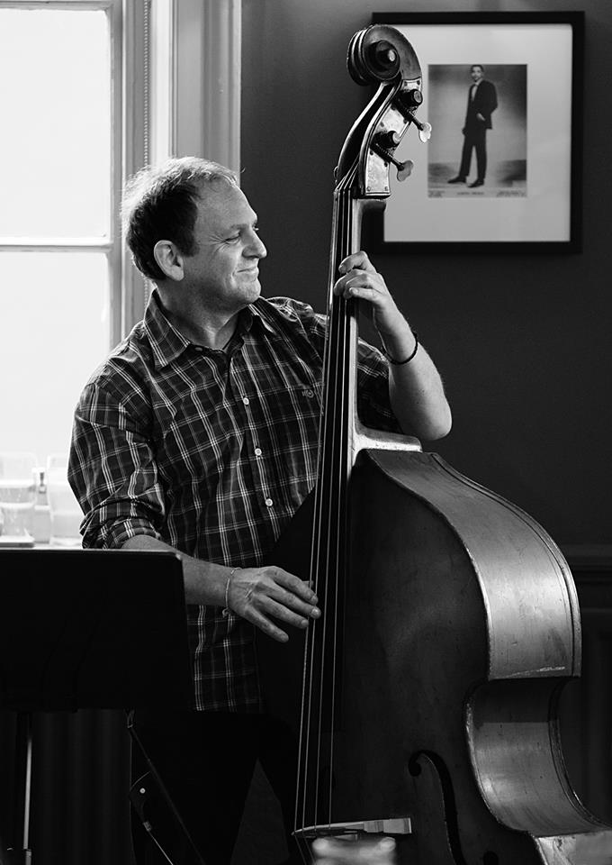
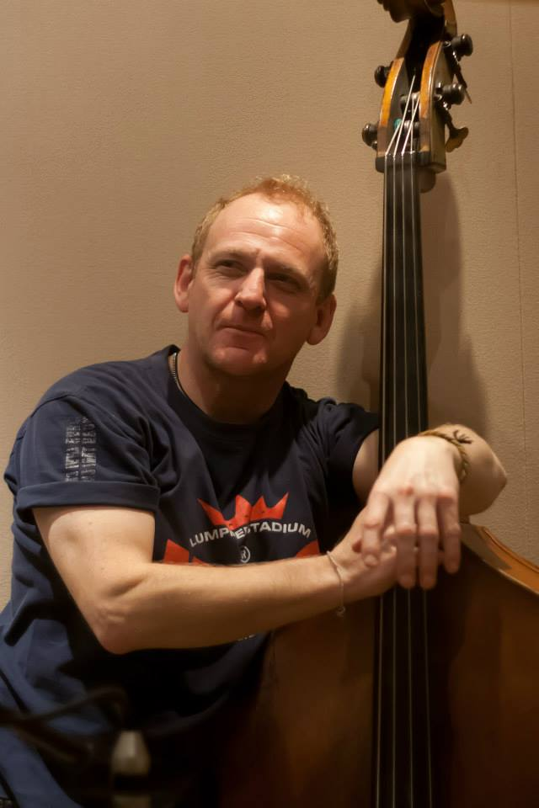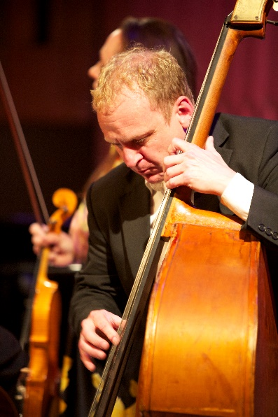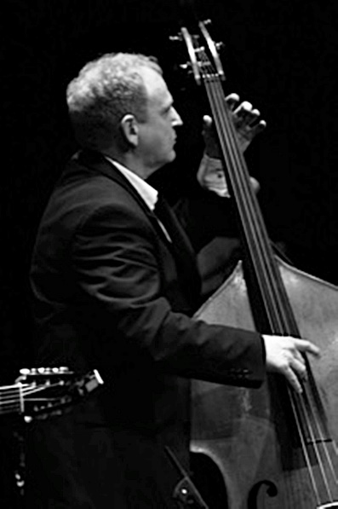

VIDEOS:
Paul Edis Sextet – ‘Mr Hipster’ https://youtu.be/C7RxLiqyCrE
Paul Edis Sextet – ‘Dorian Grey’ https://youtu.be/zeGNsYcjH5c
Djangologie – ‘Dinah’ https://youtu.be/z67ItPZXBxU
Roly Veitch/Giles Strong – ‘You’d be so nice to come home to’ https://youtu.be/i61xbjOKPQA

AUDIO:
Paul Edis Sextet – ‘Serial For Breakfast’ https://youtu.be/teYe4PjFnAg
Paul Edis Sextet – ‘Knight Errant’ https://youtu.be/4yjmoi9Khh8
Ruth Lambert Trio – ‘Three’ https://soundcloud.com/ruth-lambert-trio
Djangologie – ‘A New Leaf’ https://soundcloud.com/mick-shoulder
DISCOGRAPHY:
Citizen Kane ‘Ginocerous’ Ralph Records
‘Skankin’ Hot Cats’ Ralph Records
Voodoo Guru ‘Do’ Handshake Records
Frank Brooker/Billy Harper/Roly Veitch
‘Three and Easy’ BlaydonJazzCD
Sara D ‘Moondance’ First Flight
Emma Frampton
‘Live’ HJC CD
Wagga Jawaka
‘Warts and All (try to play the music of Frank Zappa)
WaggajawakaCD1
Dave Borthwick Trio ‘Trio’ JazzAction
John Miles (with the Dave Connelly Big Band)
‘Big Band John’ Orange Records
Paul Edis Trio with Vasilis Xenopoulis
‘Live at the Side’ PaulEdisCD1
Djangologie ‘Djangology’ DJCD1
‘Echoes’ JazzAction
‘Standards’ DJCD2
‘A New Leaf’ DJCD3
Paul Edis Sextet ‘There Will Be Time’ JazzAction
‘Mr Hipster’ PaulEdisMusic
Ruth Lambert Trio ‘Three’ RLT1

www.mickshoulder-bassplayer.com
www.twitter.com/beelzeebass
www.instagram.com/beelzebass
www.facebook.com/mickshoulder

